**VISVESVARAYA TECHNOLOGICAL UNIVERSITY**

"Jnana Sangama", Belagavi - 590018



A Report on

**AICTE ACTIVITY**

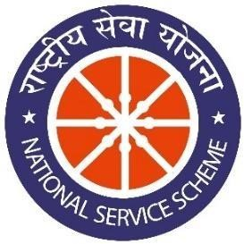

**NON CREDIT MANDATORY COURSE**

Submitted in partial fulfillment of the requirement for the award of the degree of

**Bachelor of Engineering in**

**Computer Science and Engineering**

**By**

**Aditi Das**

**1AY21CS014**

Under the guidance of

**Mrs. BHAVYASHREE S P**

**Assistant Professor**

**Department of Computer Science and Engineering**



**DEPARTMENT OF COMPUTER SCIENCE AND ENGINEERING**

**ACHARYA INSTITUTE OF TECHNOLOGY**

(Affiliated to Visvesvaraya Technological University, Belagavi) 2023-2024

# ACHARYA INSTITUTE OF TECHNOLOGY

Acharya Dr. Sarvepalli Radhakrishnan Road, Soladevanahalli, Bengaluru – 560107

(Affiliated to Visvesvaraya Technological University, Belagavi)

**DEPARTMENT OF COMPUTER SCIENCE AND ENGINEERING**



## CERTIFICATE

Certified that the report entitled **AICTE ACTIVITY - Promoting Paper Bags in Abbigere, Bangalore** activity carried out by **Aditi Das (1AY21CS014)** in partial fulfillment for the award of degree of **Bachelor of Engineering in Computer Science and Engineering of Visvesvaraya Technological University**, **Belagavi** during **5rd semester** in the year **2023-2024.** It is certified that all corrections/suggestions indicated for internal assessments have been incorporated in the report deposited in the departmental library. The activity report has been approved as it satisfies the academic requirements in respect of project prescribed for the **Bachelor of Engineering Degree**.

|  |  |  |
| --- | --- | --- |
| Signature of AICTE Coordinator | Signature of HOD | Signature of Principal |
| **Mrs Bhavyashree S P** | **Dr. Ajith Padyana** | **Dr. Rajath Hegde. M.M** |
| **Assistant Professor** | **HOD** | **Principal** |

**AICTE Officer, AIT**

**External**

**Name of Examiner Signature with Date**

1.

2.

## DECLARATION

I , student of 5th semester, B.E Computer Science and Engineering, Acharya Institute of

Technology, Bangalore, hereby declare that the activity report entitled **“AICTE Activity - Promoting Paper Bags in Abbigere, Bangalore”** is an authentic activity report of my own work carried out under the supervision and guidance of Mrs Bhavyashree S P, Assistant Professor and Aicte CSE Department Coordinator, Department of Computer Science and Engineering, Acharya Institute of Technology, Bangalore. I have not submitted the matter embodied to any other University or Institution for the award of any other degree.

Date:

Place: Bengaluru

**Aditi Das 1AY21CS014**

## ACKNOWLEDGEMENT

We express our gratitude to our institution and management for providing us with good infrastructure, laboratory, facilities and inspiring staff, and whose gratitude was of immense help in completion of this report successfully.

We are deeply indebted to **Dr. Rajeswari** Principal, Acharya Institute of Technology, Bengaluru, who has been a constant source of enthusiastic inspiration to steer us forward.

We heartily thank **Dr. Ajith Padyana**, Head of the Department, Department of Computer Science and Engineering, Acharya Institute of Technology, Bengaluru, for his valuable support and for rendering us resources for this activity.

We specially thank **Mrs. Bhavyashree S P,** Assistant Professor and AICTE Department Coordinator, Department of Computer Science and Engineering, Acharya Institute of Technology, Bangalore who guided us with valuable suggestions in completing this project at every stage.

We would like to express our sincere thanks and heartfelt gratitude to Computer Science and Engineering staff members, our beloved Parents, Respected Professors, Classmates, Friends and non-teaching staff for their indispensable help at all times.

Last but not the least our respectful thanks to the Almighty.

**Aditi Das 1AY21CS014**

### INTRODUCTION

In a commendable effort to promote environmental awareness and advocate for sustainable living practices, a group of enthusiastic college students undertook a transformative project in Abbigere, a vibrant locality in Bangalore. Driven by a shared passion for environmental conservation and a desire to make a positive impact, the team designed an awareness campaign to encourage the use of paper bags as an alternative to plastic bags. They recognized Abbigere, with its harmonious blend of urban life and natural beauty, as an ideal location for their mission.

The campaign's primary goal was to raise awareness about the detrimental ecological effects of plastic use and advocate for its reduction for the betterment of the planet. The core element of the initiative involved the distribution of eco-friendly paper bags. This served as a tangible call to action, prompting the community to embrace more sustainable choices in their daily lives.

Beyond the immediate switch from plastic to paper, the project aimed to emphasize the crucial role of afforestation in combating climate change, fostering biodiversity, and ensuring the overall health of the planet. This initiative embodies a collective spirit, striving to inspire positive change, one paper bag at a time, within the bustling community of Abbigere. The project represents a collaborative effort towards a greener and cleaner future. It aspires to cultivate a community that champions sustainable practices and fosters a sense of responsibility towards the well-being of our planet, Earth.

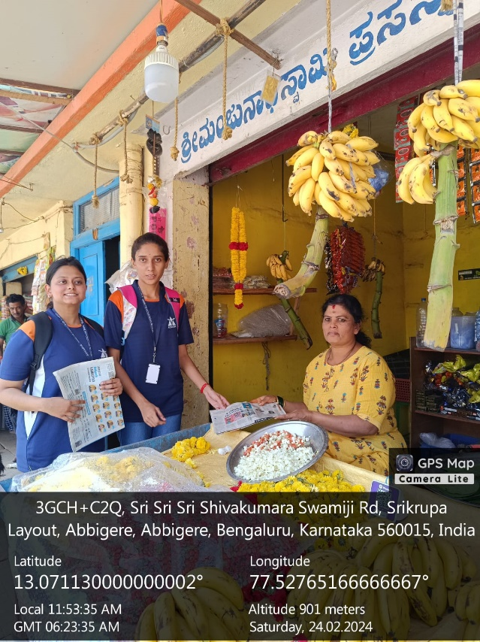

**ENCOURAGING THE ADOPTION**

**OBJECTIVE:**

In our environmental awareness campaign conducted in Abbigere, Bangalore, we prioritized the promotion of sustainable practices. This was achieved through the distribution of paper bags as a viable alternative to plastic bags. By encouraging this shift, we aimed to contribute to afforestation efforts and, consequently, the overall well-being of our planet.

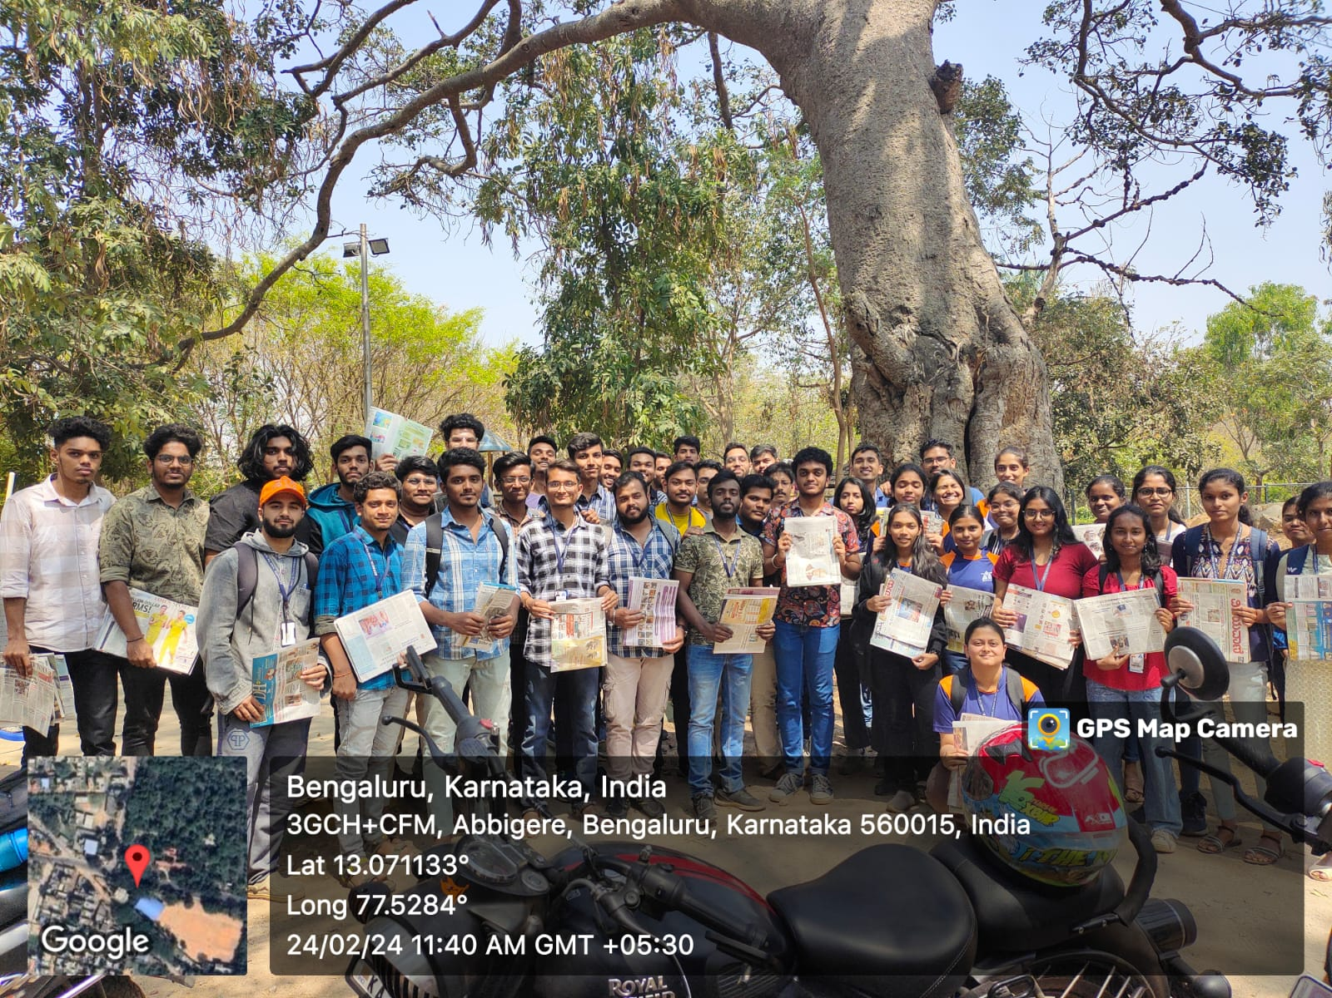

**Paper Bag Distribution:** Distribute eco-friendly paper bags extensively in Abbigere to replace plastic bags, aiming to reduce plastic consumption and waste.

**Raise Awareness:** Educate the local community about the adverse environmental impacts of plastic pollution, emphasizing the importance of transitioning to sustainable alternatives like paper.

**Raise Awareness:** Educate the local community about the adverse environmental impacts of plastic pollution, emphasizing the importance of transitioning to sustainable alternatives like paper.

**Afforestation Advocacy:** Promote afforestation initiatives by distributing informational materials and engaging in conversations that highlight the critical role of trees in mitigating climate change and ensuring the planet's safety.

**Behavioral Change:** Encourage a tangible shift in consumer behavior, inspiring individuals to choose paper over plastic for daily use, thereby contributing to a cleaner, healthier environment.

**Community Engagement:** Foster a sense of shared responsibility within the community, creating a dialogue about sustainable practices and motivating residents to actively participate in environmental preservation.

By addressing these objectives, our aim was not only to provide a practical alternative to plastic but also to catalyze a broader cultural shift towards eco-conscious living. Through these efforts, we sought to contribute to the broader mission of creating a more sustainable and secure future for our planet.

**Activities:**

1. **Distribution of Paper Bags:** The team distributed eco-friendly paper bags at key locations in Abbigere, emphasizing their advantages over plastic bags. Each bag carried a message encouraging residents to switch to paper for the well-being of the environment.

1. **Community Engagement:** Interactions with local residents were a significant aspect of our campaign. The team engaged in discussions, providing insights into the environmental impact of plastic pollution and the positive implications of using paper.
2. **Afforestation Awareness:** To underline the importance of afforestation, informational pamphlets accompanied the paper bags. These pamphlets highlighted the role of trees in mitigating climate change, promoting biodiversity, and improving overall air quality.

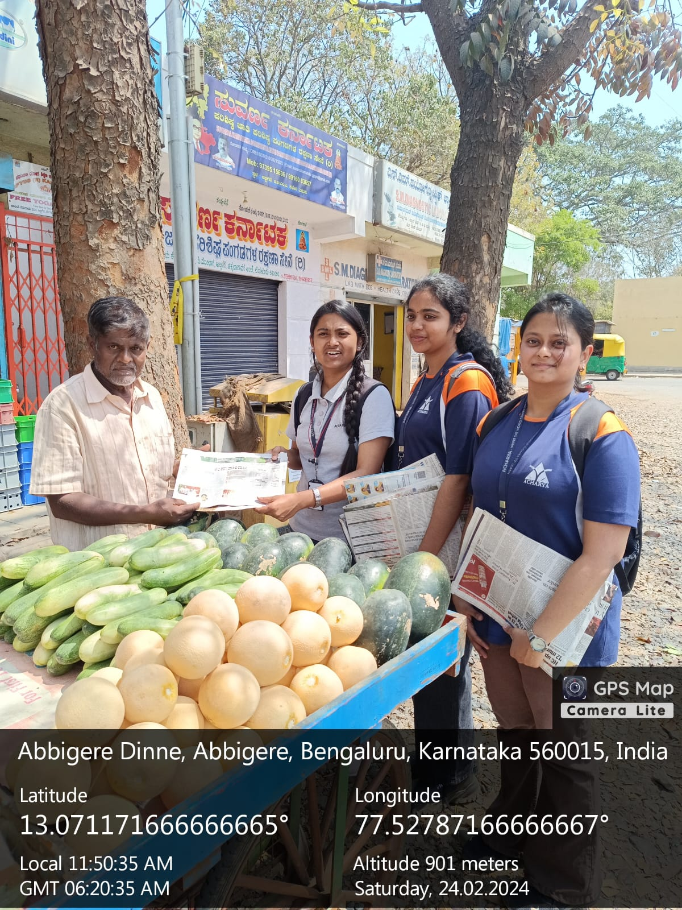

**Response and Impact:**

The response from the community was overwhelmingly positive. Residents expressed a heightened awareness of the environmental consequences of plastic usage and a genuine interest in adopting sustainable alternatives. Many community members pledged to reduce their reliance on plastic bags and actively participate in afforestation initiatives.

**Positive Community Engagement:**

Residents of Abbigere exhibited a commendable willingness to engage in discussions about the harmful effects of plastic on the environment. Conversations were marked by genuine curiosity, with many expressing a newfound understanding of the urgent need to transition towards more sustainable alternatives.

**Adoption of Paper Bags:**

The distribution of eco-friendly paper bags yielded tangible results as residents actively incorporated them into their daily lives. Many community members enthusiastically embraced the shift from plastic, recognizing the positive environmental implications and pledging to continue this eco-friendly choice.

**Afforestation Pledges:**

Our campaign's emphasis on afforestation as a solution to environmental challenges resonated deeply with the community. Informational pamphlets distributed alongside the paper bags sparked discussions about the crucial role of trees, leading to pledges from residents to support local afforestation initiatives.

**Behavioural Change:**

The campaign has catalyzed a noticeable behavioral change within the community. Individuals are making conscious decisions to reduce their reliance on plastic, contributing to a cleaner and safer local environment. The sight of residents proudly using paper bags has become a symbol of a collective commitment to sustainable living.

**Educational Impact:**

Beyond immediate actions, the campaign has left a lasting educational impact. Awareness about the environmental consequences of plastic pollution has grown, creating a community that is more informed and empowered to make environmentally conscious choices.

**Challenges:**

While the majority of residents embraced the initiative, there were challenges in changing ingrained habits. Some individuals were initially resistant to the transition from plastic to paper. However, through open conversations and informative discussions, these challenges were effectively addressed.

**Challenges Faced:**

**Behavioural Resistance:**

Encouraging a shift from entrenched habits proved challenging. Some community members were initially resistant to adopting paper bags, emphasizing the need for persistent education to break through pre-existing norms.

**Limited Awareness:**

Despite our efforts, a segment of the population in Abbigere exhibited limited awareness about the environmental impact of plastic. Overcoming this challenge required targeted educational strategies to convey the urgency of transitioning to more sustainable practices.

**Communication Barriers:**

Language and communication barriers were encountered during interactions with diverse groups in Abbigere. Tailoring our messaging and educational materials to cater to various linguistic and cultural nuances was crucial to effectively convey our environmental message.

**Long-Term Commitment:**

Sustaining community engagement and commitment to eco-friendly practices requires ongoing effort. Ensuring that the momentum gained during the campaign translates into enduring behavioural change poses an ongoing challenge.

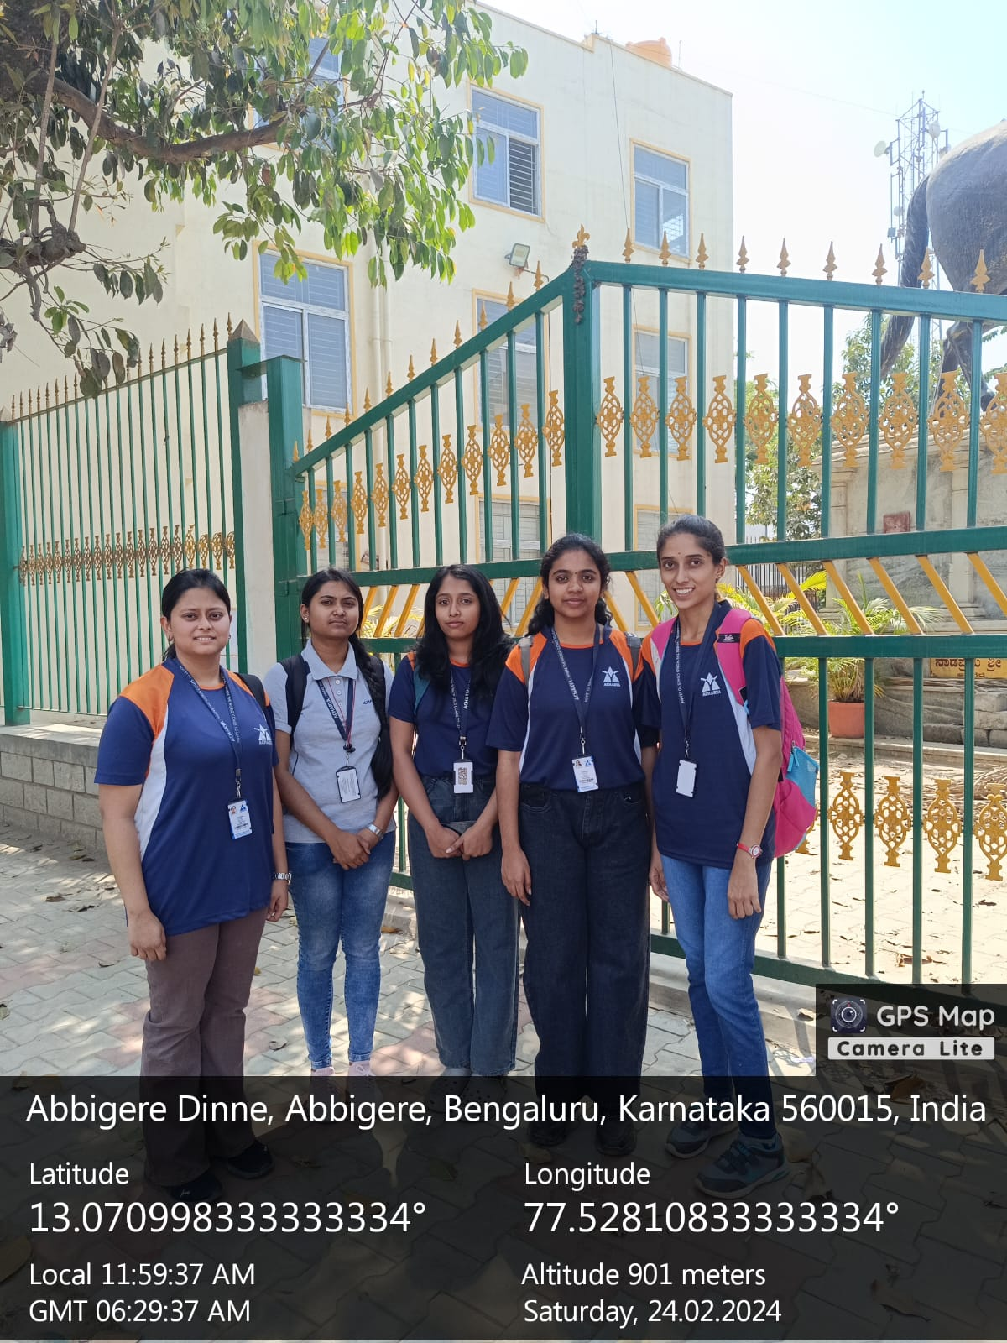

**CONCLUSION**

The environmental awareness campaign in Abbigere proved to be a significant step towards promoting sustainable practices and reducing plastic pollution. The distribution of paper bags not only provided a tangible alternative but also initiated essential conversations about responsible environmental stewardship. The campaign underscored the power of grassroots initiatives in creating positive change and fostering a sense of collective responsibility for the planet's well-being.

Paving the Path to Sustainability in Abbigere Our venture to Abbigere stands as a testament to the potential of collective action and community engagement in championing environmental sustainability. As a group of college students, our mission to distribute paper bags and raise awareness about the perils of plastic has left an indelible impact on both the community and the local environment.

Our journey to Abbigere has been a catalyst for positive change. The impact achieved, both immediate and long-term, speaks to the potential of grassroots initiatives led by passionate individuals. As the echoes of our campaign resonate, we remain hopeful that the seeds of change planted in Abbigere will blossom into a thriving culture of sustainability, contributing to the greater good of our shared home—Earth. The journey continues, propelled by the belief that each small action contributes to a planet that is safer, healthier, and more resilient.